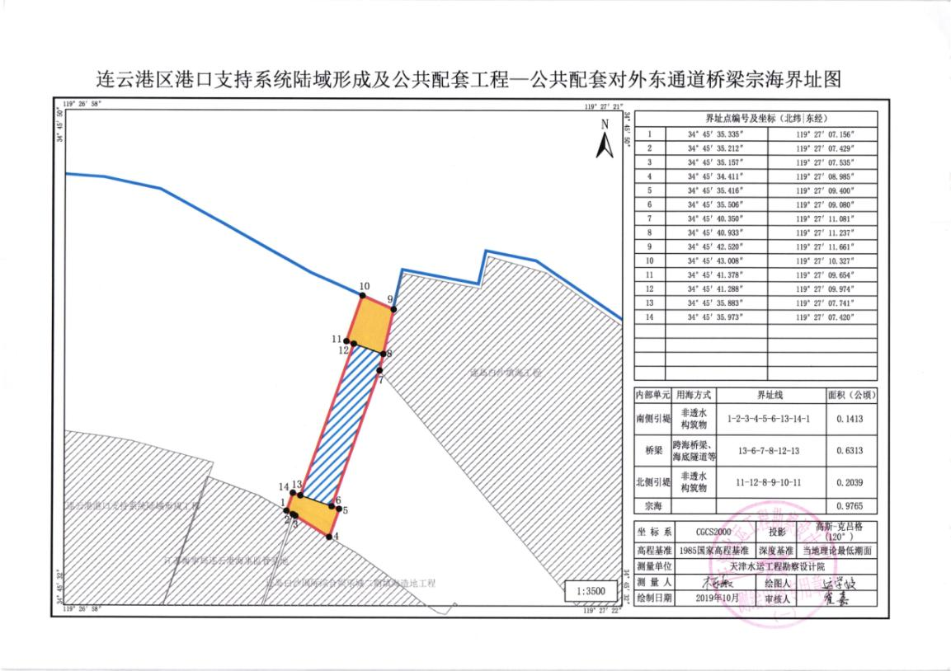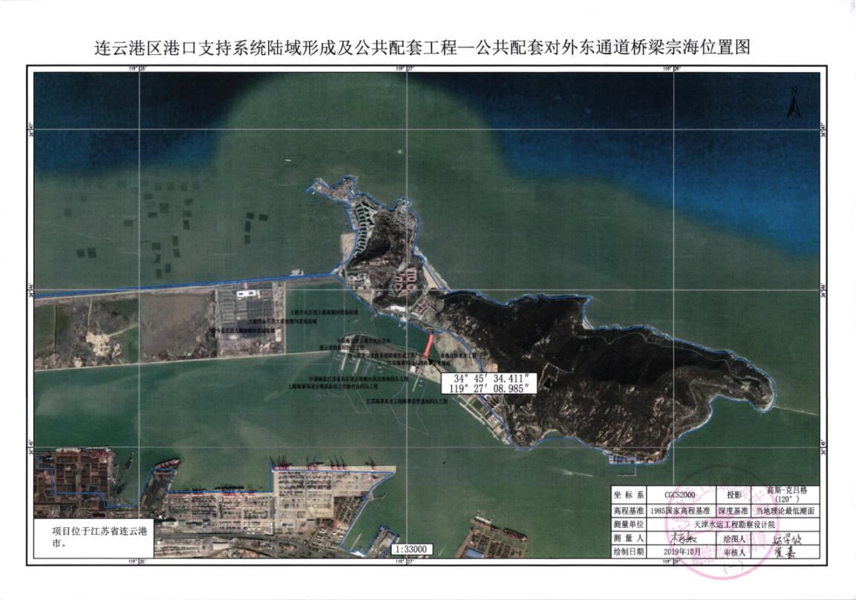

界址点坐标
顶 点 坐 标
序号 | 北纬 | 东经 | 序号 | 北纬 | 东经
1 | 34°45′35.335″ | 119°27′07.156″ | 8 | 34°45′40.933″ | 119°27′11.237″
2 | 34°45′35.212″ | 119°27′07.429″ | 9 | 34°45′42.520″ | 119°27′11.661″
3 | 34°45′35.157″ | 119°27′07.535″ | 10 | 34°45′43.008″ | 119°27′10.327″
4 | 34°45′34.411″ | 119°27′08.985″ | 11 | 34°45′41.378″ | 119°27′09.654″
5 | 34°45′35.416″ | 119°27′09.400″ | 12 | 34°45′41.288″ | 119°27′09.974″
6 | 34°45′35.506″ | 119°27′09.080″ | 13 | 34°45′35.883″ | 119°27′07.741″
7 | 34°45′40.350″ | 119°27′11.081″ | 14 | 34°45′35.973″ | 119°27′07.420″

